|  |  |  |
| --- | --- | --- |
| samblem | **ÇANKAYA UNIVERSITY**  **Software Engineering Department** |  |

**SENG 491 – 492 Graduation Project**

**Software Design**

**Description**

**<<Project Name>>**

**<<Project Members>>**

**Version <<1.0>>**

Table of Contents

1 Introduction 1

1.1 Purpose 1

1.2 Scope 1

1.3 Definitions, acronyms, and abbreviations 1

1.4 References 1

1.5 Overview 1

1.6 Version History 1

2 Architecture 1

2.1 Clients 2

2.1.1 Mobile Phones 2

2.1.2 Tablets 2

2.1.3 Personal Computers 2

2.2 Application Server 2

2.3 Database Server 2

3 User Interface 2

3.1 Screen 1 3

3.2 Screen 2 3

3.3 … 3

4 High Level Design 3

4.1 Module 1 4

4.2 Module 2 4

4.3 Module ... 4

5 Low Level Design 4

5.1 Module 1 5

5.2 Module 2 5

5.3 Module … 5

6 Database Design 5

6.1 E-R Diagram 5

6.2 Tables 5

6.2.1 Table 1 5

6.2.2 Table 2 5

6.2.3 Table … 5

7 References 6

# Introduction

## Purpose

This subsection should

1. Delineate the purpose of the SDD;
2. Specify the intended audience for the SDD.

## Scope

This subsection should describe the scope of this document, what it will cover and will not cover, intended audience, …

## Definitions, acronyms, and abbreviations

This subsection should provide the definitions of all terms, acronyms, and abbreviations required to properly interpret the SDD. This information may be provided by reference to one or more appendixes in the SDD or by reference to other documents.

## References

This subsection should

1. Provide a complete list of all documents referenced elsewhere in the SDD;
2. Identify each document by title, report number (if applicable), date, and publishing organization;
3. Specify the sources from which the references can be obtained.

If the list of references is too long, it should be provided at the end of the document as a separate section.

## Overview

This subsection should

1. Describe what the rest of the SDD contains;
2. Explain how the SDD is organized.

## Version History

Provide a table of table of changes to this document

|  |  |  |
| --- | --- | --- |
| **Version No** | **Description of change** | **Date** |
| 1.0 | Initial Release | 15.10.2024 |
|  |  |  |

# Architecture

Provide a hardware diagram and provide specifications for each

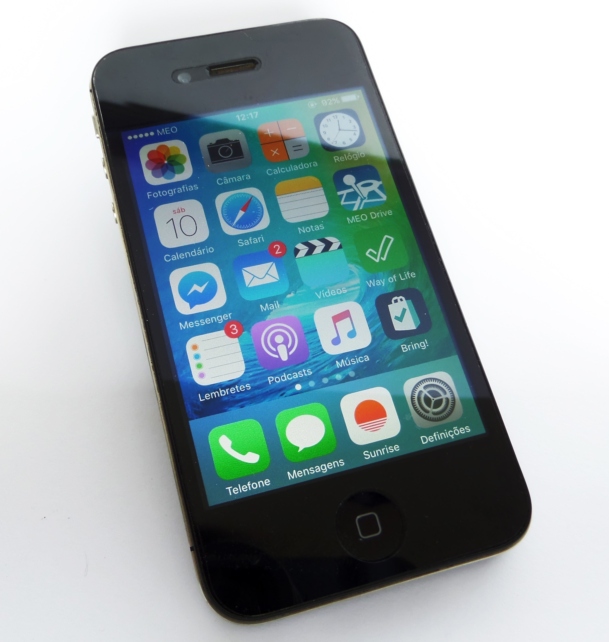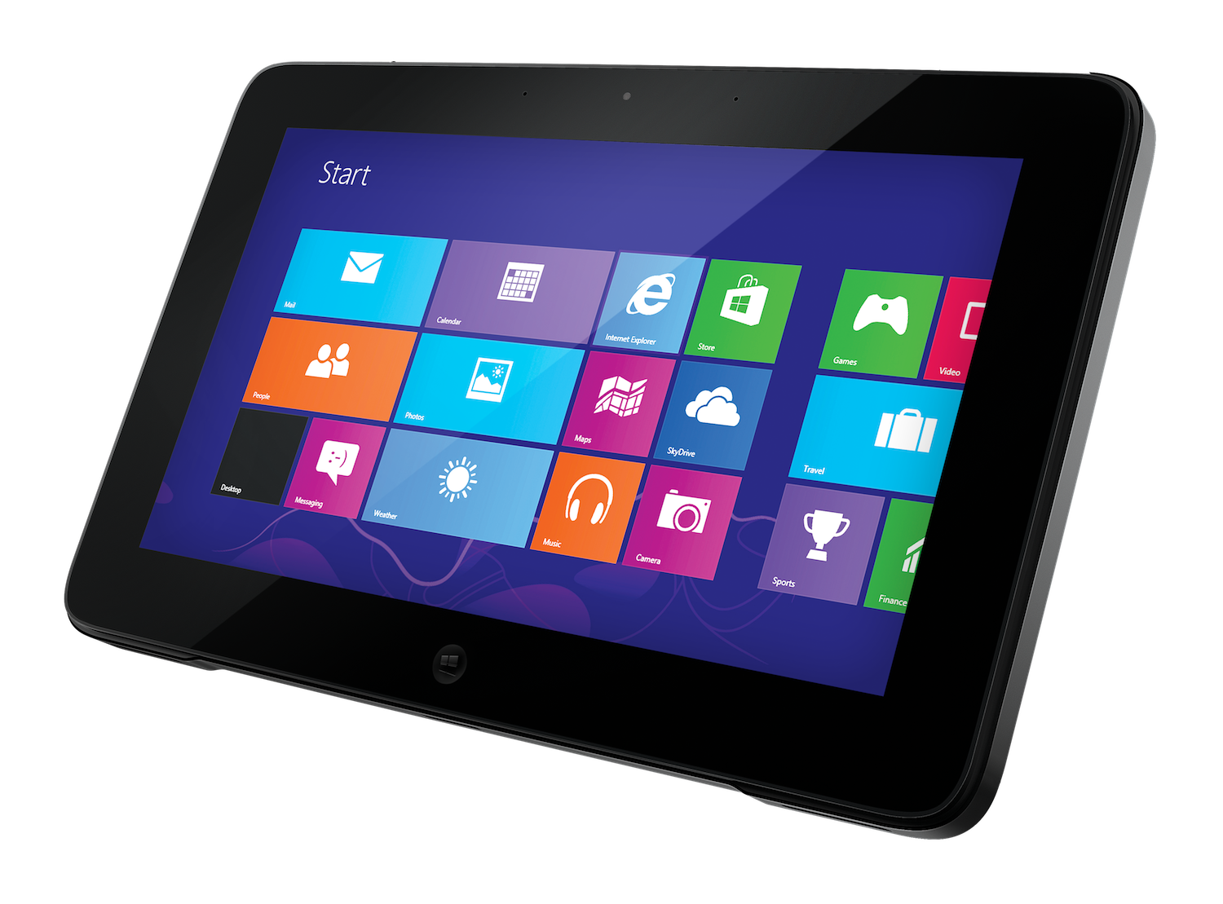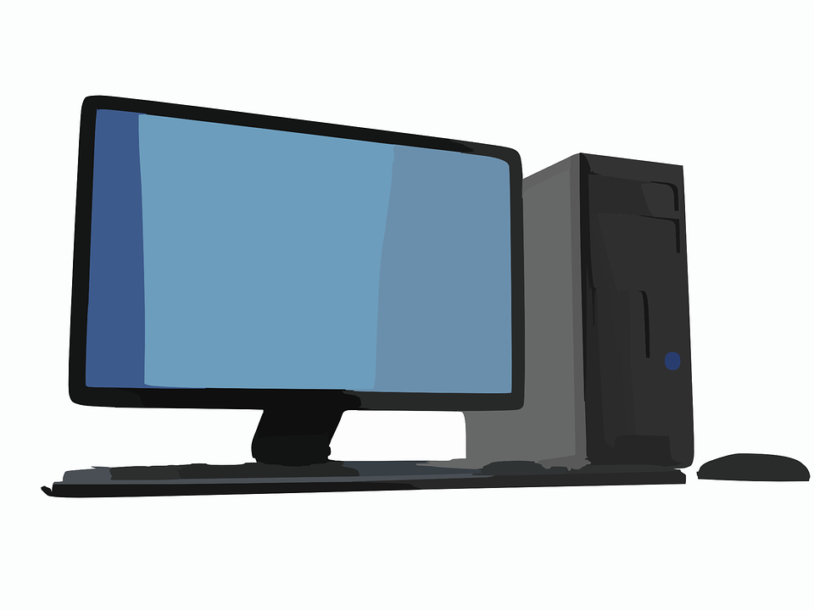

Clients

Internet

Application Server

Database Server

## Clients

### Mobile Phones

**Minimum Requirements:**

* OS: Android 8.0 (Oreo) or iOS 13.0 and above.
* RAM: Minimum 2 GB (recommended 4 GB or more).
* Storage: At least 150 MB available space.
* Network: Active internet connection (Wi-Fi or 4G/5G recommended).

### Tablets

• **Minimum Requirements:**

* OS: Android 8.0 (Oreo) or iOS 13.0 and above.
* RAM: Minimum 2 GB (recommended 4 GB or more).
* Storage: At least 150 MB available space.
* Network: Active internet connection (Wi-Fi or 4G/5G recommended).

### Personal Computers

Bilgisayarı yazacak mıyız mobil app’I masaüstü uygulamaya çevircek miyiz?

• **Minimum Requirements:**

* OS: Windows 10 or macOS 10.15 (Catalina) and above.
* RAM: Minimum 4 GB.
* Storage: At least 200 MB available space.
* Network: Active internet connection.

## Application Server

• **Minimum Requirements:**

* OS: Ubuntu 20.04 LTS or Windows Server 2019.
* CPU: Quad-core processor.
* RAM: Minimum 8 GB.
* Storage: At least 500 GB available space.
* Network: High-speed internet connection with static IP.

## Database Server

• **Minimum Requirements:**

* OS: Ubuntu 20.04 LTS or Windows Server 2019.
* CPU: Quad-core processor.
* RAM: Minimum 16 GB.
* Storage: At least 1 TB SSD.
* Network: High-speed internet connection.

# User Interface

## Login Page

|  |  |
| --- | --- |
| Title | SenseAI |
| E-mail Field | Field where the user will enter his/her e-mail address. Accepts data only in e-mail format. |
| Password Field | The field where the user will enter the password. The characters are displayed hiddenly. |
| Remember Me Checkbox | Provides the option for the user to remember their login information. |
| Sign In Button | The main action button that allows the user to log in. |
| Google Login Icon | Icon that allows you to log in with a Google account. |
| Sign Up Link | Referral link for user to create account |
| Forgot Password Link | Allows the user to go to the reset screen when they forget their password. |

## Sign Up Page

|  |  |
| --- | --- |
| Title | SenseAI |
| Username Field | Textbox for entering the user's username. |
| E-mail Field | Field where the user will enter his/her e-mail address. Accepts data only in e-mail format. |
| Password Field | The field where the user will enter the password. The characters are displayed hiddenly. |
| Checkbox | Checkbox labeled *"I have read and agree to the term of service"*. Users must check this box before signing up. |
| Sign Up Button | Main button for account creation, highlighted in purple. |
| Google Sign-Up Button | Secondary button with Google icon for signing up via Google authentication. |
| Sign In Link | Text link for existing users to navigate to the login page. Label: *"You already have an account? Sign in"* |

## Main Page

|  |  |
| --- | --- |
| Title | SenseAI |
| Chat History Section | Button with text and a right arrow for accessing previous chat sessions. Label: *"Chat history"*. |
| My Inbox Section | Button with text for accessing a note-taking feature. Placeholder: *"Write down your thoughts"*. |
| Self-Care | A section displaying gradient-colored cards/buttons representing various self-care activities or tools. |
| Home Button | Tab with a home icon for navigating to the main page. |
| Chat Button | Tab with a chat bubble icon for accessing chat page. |
| User Profile Button | Tab with a user icon for see account details. |
| 3 Dots Button | Tab with 3 dots icon for managing account. |

## AI Chat Page

|  |  |
| --- | --- |
| Date and time | Shows last conversation time. |
| Paperclip Button | Shows the options for the type of data to be sent. |
| Moon Button | Button that changes dark mode/light mode. |
| Heart Rhythm Button | Chatbot allows biometric data collection. |
| Camera Button | Chatbot allows to get photo data. |
| Video Button | Chatbot allows to get video data. |
| Microphone Button | Receives voice data from the user for the text-to-speech feature. |
| Purple Speech Bubble | Shows the query sent by the user to the chatbot. |
| Gray Speech Bubble | Shows the answers the chatbot returns to the user. |
| Keyboard | Used to receive text data from the user. |
| Back Button | Redirects to the previous page. |

## Chat History Page

|  |  |
| --- | --- |
| Title | SenseAI |
| Sub-Title | Recent chats |
| Title(in box) | Shows the title of the chat. |
| Date | Shows the chat’s date. |
| Pen Button | Edit the chat. |
| Bin Button | Delete the chat. |
| Search Button | Search the chat from the chats. |
| Sub-Title | Previous 7 days |
| Plus Button | Redirects to the chat page to add a new chat. |
| Back Button | Redirects previous page. |

## User Profile Page

|  |  |
| --- | --- |
| Title | Hey,[username] |
| Sub-Title | Last Conversation |
| Date and time | Shows the last conversation date and time. |
| Sub-Title | Mood |
| Mood Field | Shows mood type. |
| Mood Icon | Shows mood icon. |
| Sub-Title | We talked about. |
| Chat name field | Shows the lastest chat title. |
| Start Conversation Title | Tab for start new chat. |
| Sub-Title | How are you feeling today? |
| Mood Icons | User select for the day mood. |
| Home Button | Tab with a home icon for navigating to the main page. |
| Chat Button | Tab with a chat bubble icon for accessing chat page. |
| User Profile Button | Tab with a user icon for see account details. |
| Wheel Button | Tab with wheel icon for manage account. |

## Admin Pages

|  |  |
| --- | --- |
| Title | Hey,[username] |
| Sub-Title | Admin Panel |
| Wheel Button | Tab with wheel icon for manage account. |
| Review User Record | Shows users record page to admin. |
| User Access Control Button | Shows user access control page to admin. |

### User Record Page

|  |  |
| --- | --- |
| Title | User List |
| User Fields | Shows users as a list. |
| Search Button | Admin searchs users with ID or username. |
| Select User Button | Tab the one of user then tab to this button for select the user. |
| Wheel Button | Tab with wheel icon for manage account. |

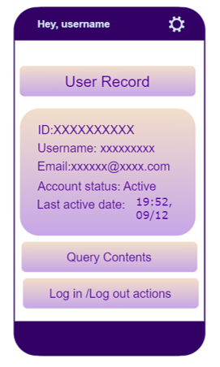

|  |  |
| --- | --- |
| Title | Hey,[username] |
| Sub-Title | User Record |
| Record Field | Shows the record informations of user to admin. |
| Query Contents | Redirected query content page. |
| Log in/Log out actions | Redirected log in/out actions page. |
| Wheel Button | Tab with wheel icon for manage account. |

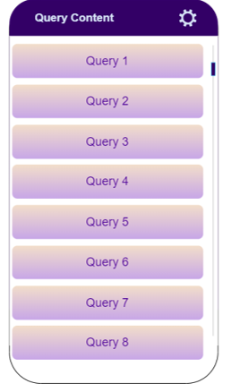

|  |  |
| --- | --- |
| Title | Query Content |
| Query Botton | Shows the queries to admin. Tab to see information about query. |
| Wheel Button | Tab with wheel icon for manage account. |

|  |  |
| --- | --- |
| Title | Log in/out actions |
| Logged in/out Fields | Shows the login/out informations of user to admin. |
| Date and time | Shows users log in/out information to admin. |
| Wheel Button | Tab with wheel icon for manage account. |

### User Access Control Page

|  |  |
| --- | --- |
| Title | User List |
| User Fields | Shows users as a list. |
| Search Button | Admin searchs users with ID or username. |
| Select User Button | Tab the one of user then tab to this button for select the user. |
| Wheel Button | Tab with wheel icon for manage account. |

|  |  |
| --- | --- |
| Title | User Access Control |
| User ID Field | Shows user’s ID infprmation. |
| User Info Field | Shows the information of user. |
| Sub-Title | Change Role |
| Make Admin Button | Tab to button form changing user role. |
| Sub-Title | Block the user. |
| Block Button | Tab to block the user. |
| Sub-Title | Manage Access |
| Manage Button | Tab to manage accessing of user. |
| Wheel Button | Tab with wheel icon for manage account. |

## Forgot Password Pages

|  |  |
| --- | --- |
| Title | SenseAI |
| Explanation Part | Explanation for directing user. |
| E-mail Field | Field where the user will enter his/her e-mail address. Accepts data only in e-mail format. |
| Submit Button | Submit for e-mail address. |
| Back to Sign In Link | Redirected user Sign In Page. |
| Google Sign-Up Button | Secondary button with Google icon for signing up via Google authentication. |

|  |  |
| --- | --- |
| Title | SenseAI |
| New Password Field | Field where the user will enter new password. |
| Verify Password Field | Field where the user will verify new password. |
| Reset Password Button | Button for resetting password. |
| Explanation Part | Explains the new password constraints. |

## Settings Page

BURAYA TABLO EKLENECEK

# High Level Design

Provide a diagram of the modules and how they interact with each other. Explain each module briefly. If Object Oriented Design is used, provide a class diagram and how each class interacts with each other.

Control Module

Main Module

Control Module

Application Module

Application Module

Control Module

Application Module

Application Module

Application Module

Application Module

## Module 1

Brief Description.

## Module 2

Brief Description.

## Module ...

# Low Level Design

For each module provide a flowchart or activity diagram and describe the flow of the module.

## Module 1



## Module 2

## Module …

# Database Design

Provide an E-R diagram and a description of each table.

## E-R Diagram

## Tables

### Table 1

List all the attributes of the table and provide the characteristics of each attribute (Key, Type, size, etc.)

### Table 2

List all the attributes of the table and provide the characteristics of each attribute (Key, Type, size, etc.)

### Table …

# References

The resources used to produce this document should be listed here and referenced in the relevant text of this document

|  |  |
| --- | --- |
| [1] | Software Engineeering Department, "Graduation Projects," SENG, [Online]. Available: https://seng.cankaya.edu.tr/graduation-projects/. [Accessed 28 June 2024]. |